Live in Vintage Splendor at El Cortez
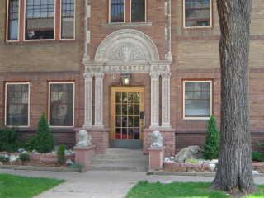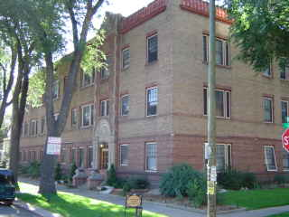
608 E. 12th Avenue
Elegance abounds in this Spanish inspired treasure. Meticulously restored to reflect the original grandeur, El Cortez is truly a site to see! Located in the heart of Capitol Hill, just blocks from Daz- Bog & Starbucks Coffee Shops, Whole Foods Market, King Soopers Grocery Store, and Trader Joe’s this historic classic is truly an urban oasis. Charming apartments feature hardwood floors, cottage style kitchens with full size appliances, and original vintage detailing. On-site laundry, additional storage, and off street parking make this an exceptional find! Best yet, all utilities included!!
Building features:
- Custom designed landscaping
- Period style lighting
- Meticulously restored common areas
- Elegant wall treatments
- Controlled access building
- Onsite laundry
- Storage lockers
- Non-smoking building & apartments
- Reserved parking available
Apartments feature:
- Spacious living rooms and bedrooms
- Newly refinished hardwood floors
- Designer paint schemes, new lighting
- Cottage style kitchens w/ original farm sinks, restored cabinets, new black/white tile and new appliances
- Abundant closet space
- Crystal door knobs
- Large windows – Lots of natural light

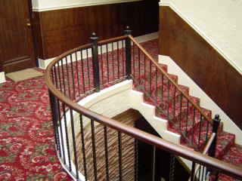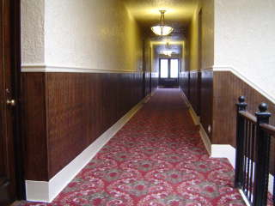
El Cortez offers distinctive living just minutes from Downtown
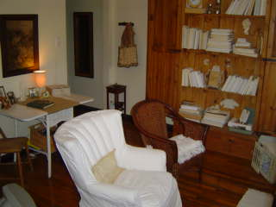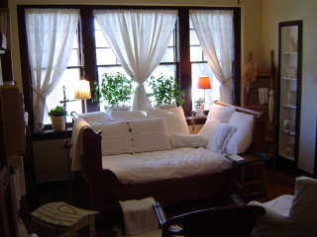

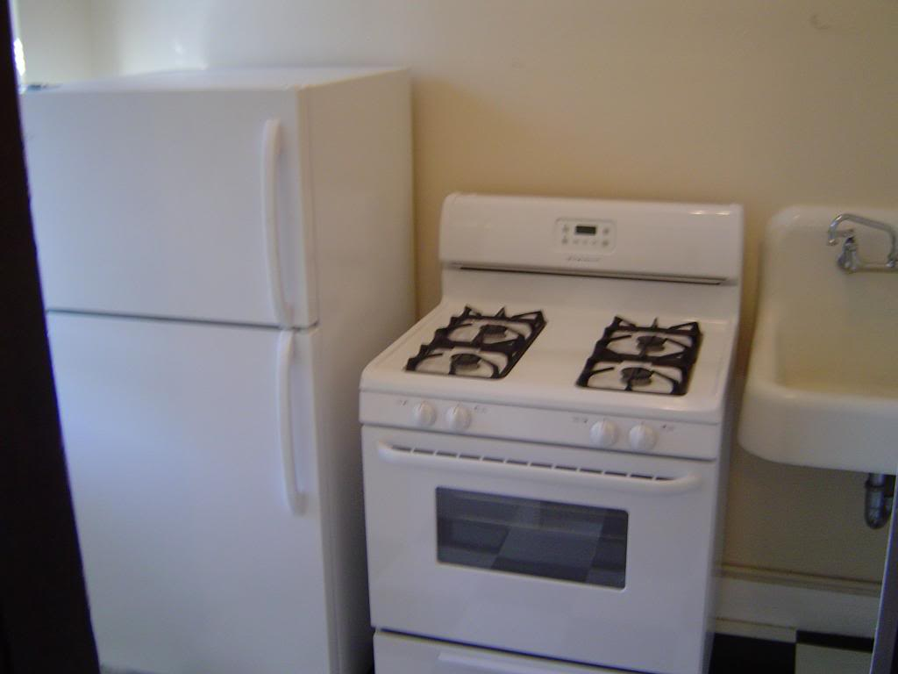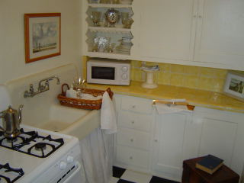

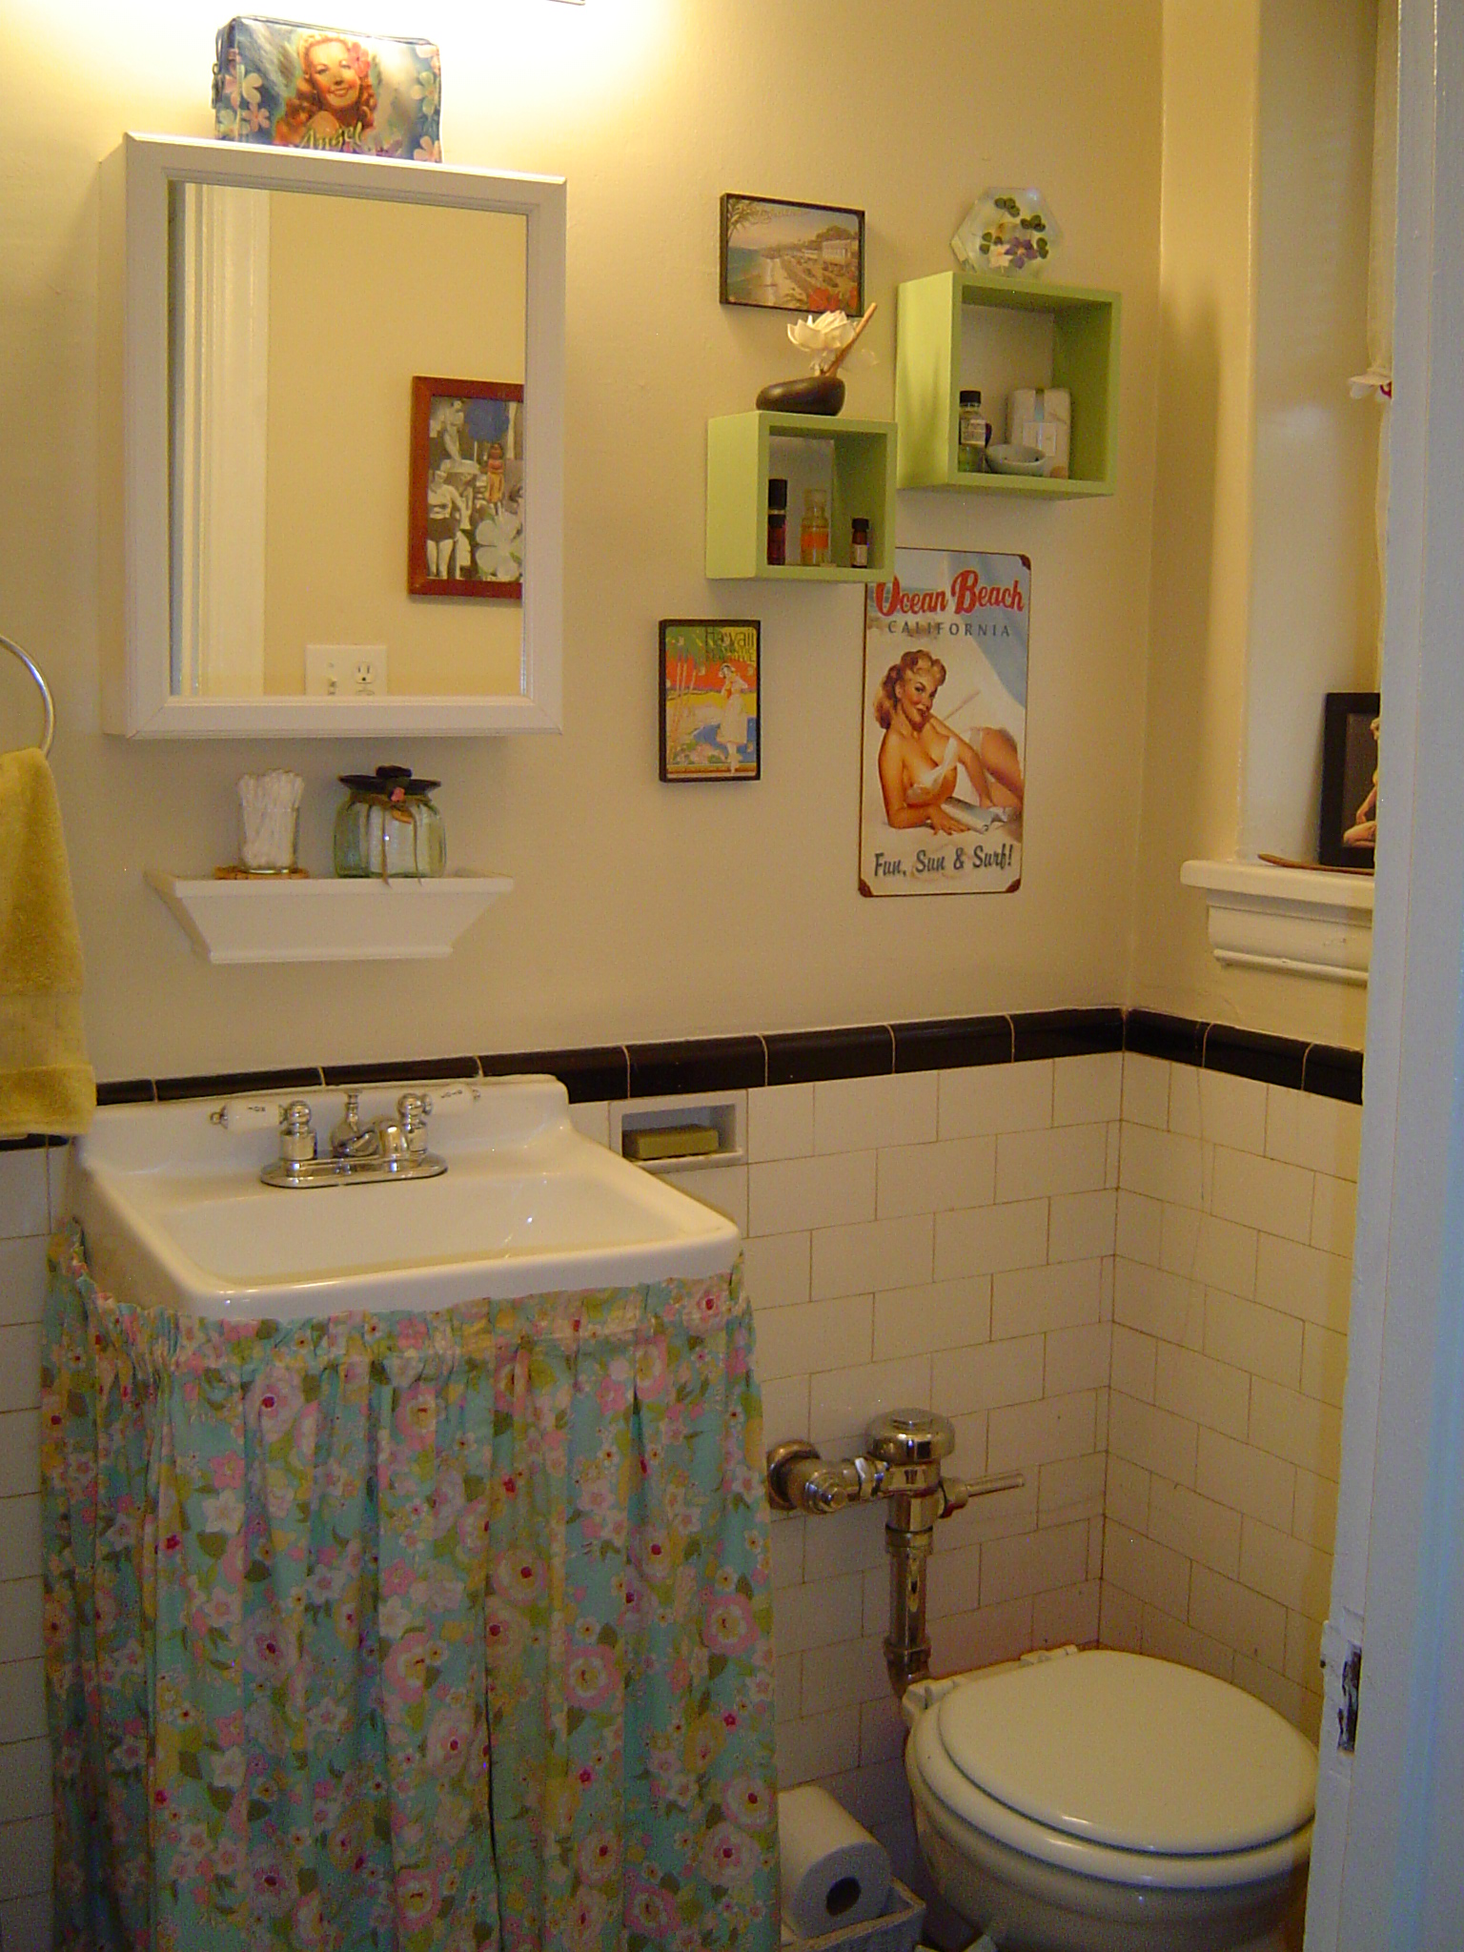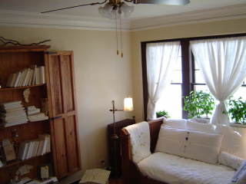

Charming studios: $965 - $1,045
Spacious 1 bedrooms: $1,145 - $1,295
ALL UTILITIES INCLUDED!!

