Live in Vintage Splendor at The Kentom

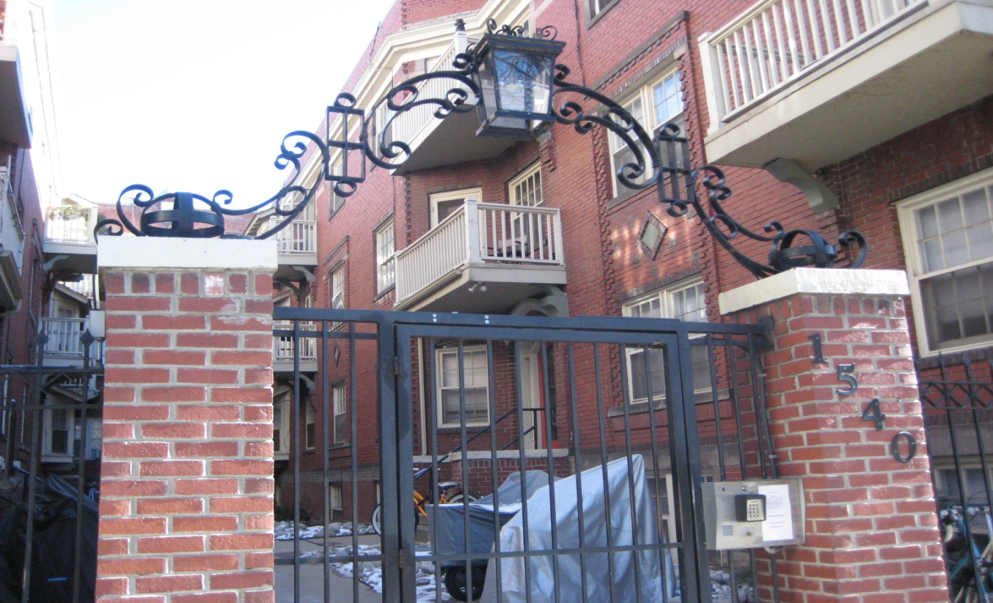
1540 Grant Street
Denver, Colorado 80203

Built in 1908, this Victorian classic exemplifies charm and elegance. Considered Capitol Hill’s Crown Jewel, The Kentom is a rare Denver Landmark. Poised around an enchanting courtyard, this oasis in the city is truly a sight to see. Inviting common areas feature original golden oak staircases, richly patterned carpets and Vintage inspired lighting. This historic property is within walking distance of Denver’s most popular restaurants, Coffee Houses and City attractions. Apartments feature hardwood floors, vintage detailing, large windows, and loads of charm.

Apartments feature:
- All utilities included except electric
- Gleaming hardwood floors
- Beautiful Crown moldings & trim
- Designer Paint Schemes
- Restored Kitchens
- Clawfoot tubs
- French Doors, Fireplaces (select units)

Building features:
- Gated Courtyard entrance
- Onsite Laundry Facilities
- Onsite Storage
- Patio and Grilling area
- Vintage Style carpeting and lighting
- Balcony space - (in select units)
- Non smoking building & apartments

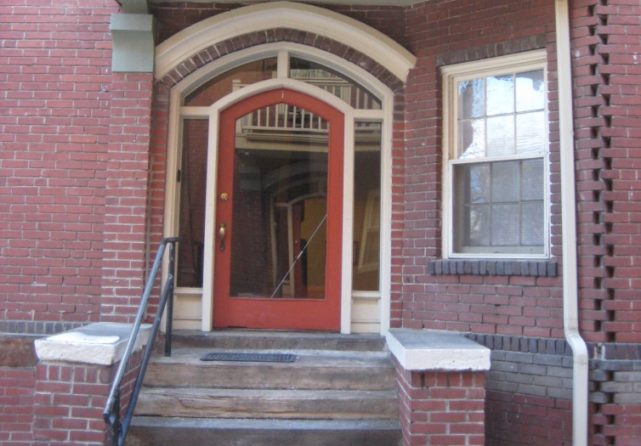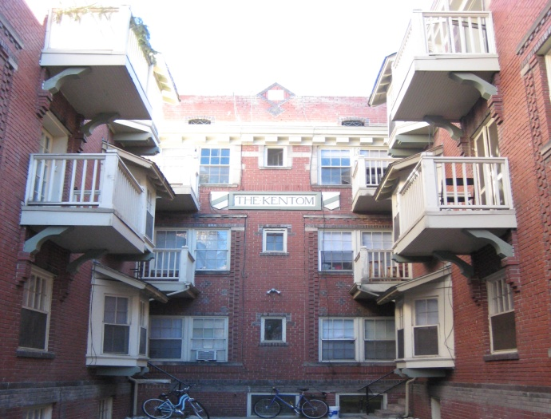
Gothic inspired entrances welcome you home Enchanting Courtyard creates an urban oasis

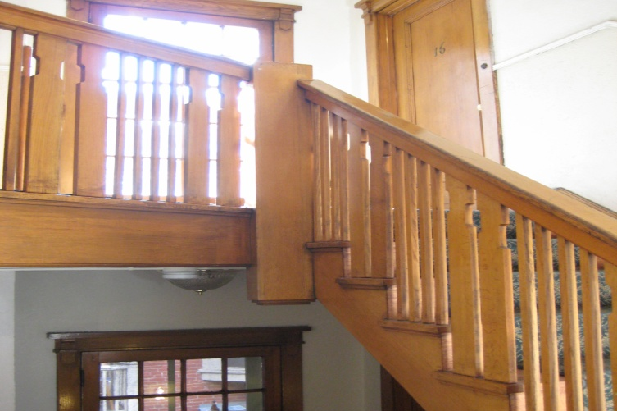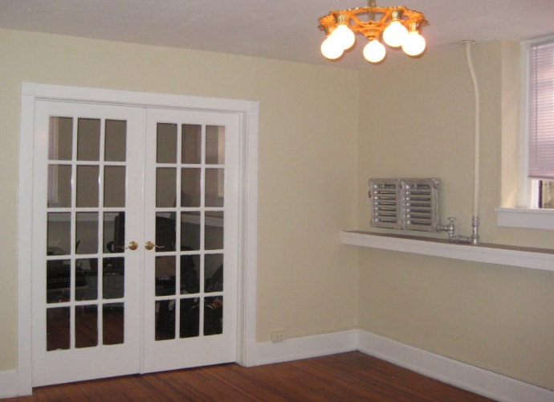
Classic Victorian style graces the common areas Distinctive and Charming living space

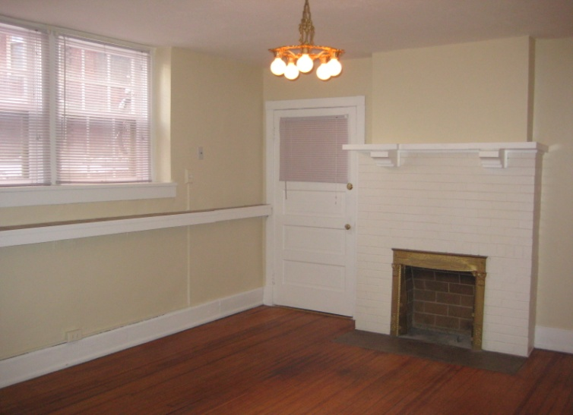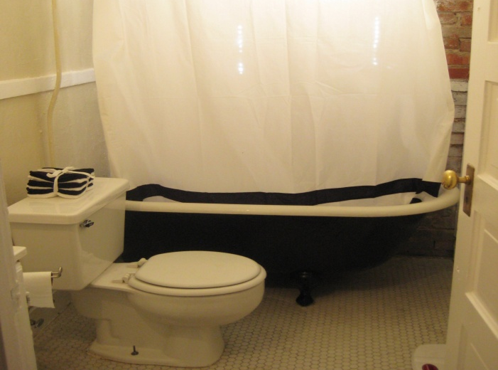

*Spacious 1 bedrooms $825-$895, *1 bedroom plus Study $925-$1095
*Large 2 bedrooms $1025-$1195 All utilities included except electricity and gas for stove.

