The Leetonia
Elegance abounds in this Art Deco Masterpiece
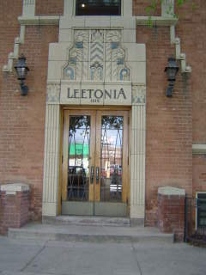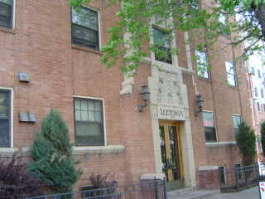
1515 Vine Street
The Leetonia is located minutes from downtown and within walking distance of great restaurants, coffee houses, and boutique shops. Built in 1930, this captivating Art Deco Classic reflects the splendor of the past. Spacious studio & 1 bedroom apartments feature hardwood floors, designer paint schemes, restored mahogany woodwork, charming Cottage style kitchens and restored bathrooms with original subway tile. Walk to City Park and Cheesman Park, the Tattered Cover book store, and St. Mark’s Coffee house—all within 4 blocks! Discover why The Leetonia is Historic Living at its finest.
Building features:
- Gracious hallways feature patterned carpets, Terrazzo marble flooring, and Art Deco Chandeliers
- Controlled access building
- Onsite Laundry
- Parking Available for $30/month
- Fabulous location, easy Bus access- walk to City Park or Cheesman Park

Apartments feature:
- Beautiful hardwood floors
- High ceilings
- Designer paint schemes, Vintage Inspired lighting
- Charming Cottage Style kitchens
- Great closet space
- Original Art Deco hardware
- Large windows allow for lots of natural light
- ALL UTIILITIES INCLUDED

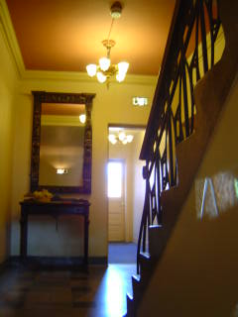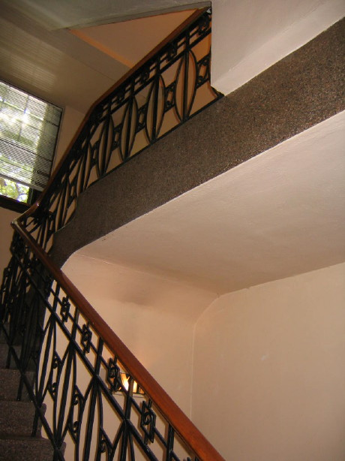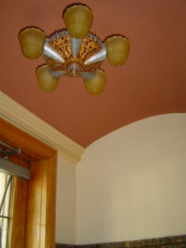

The Leetonia offers Historic Living in a charming urban setting!

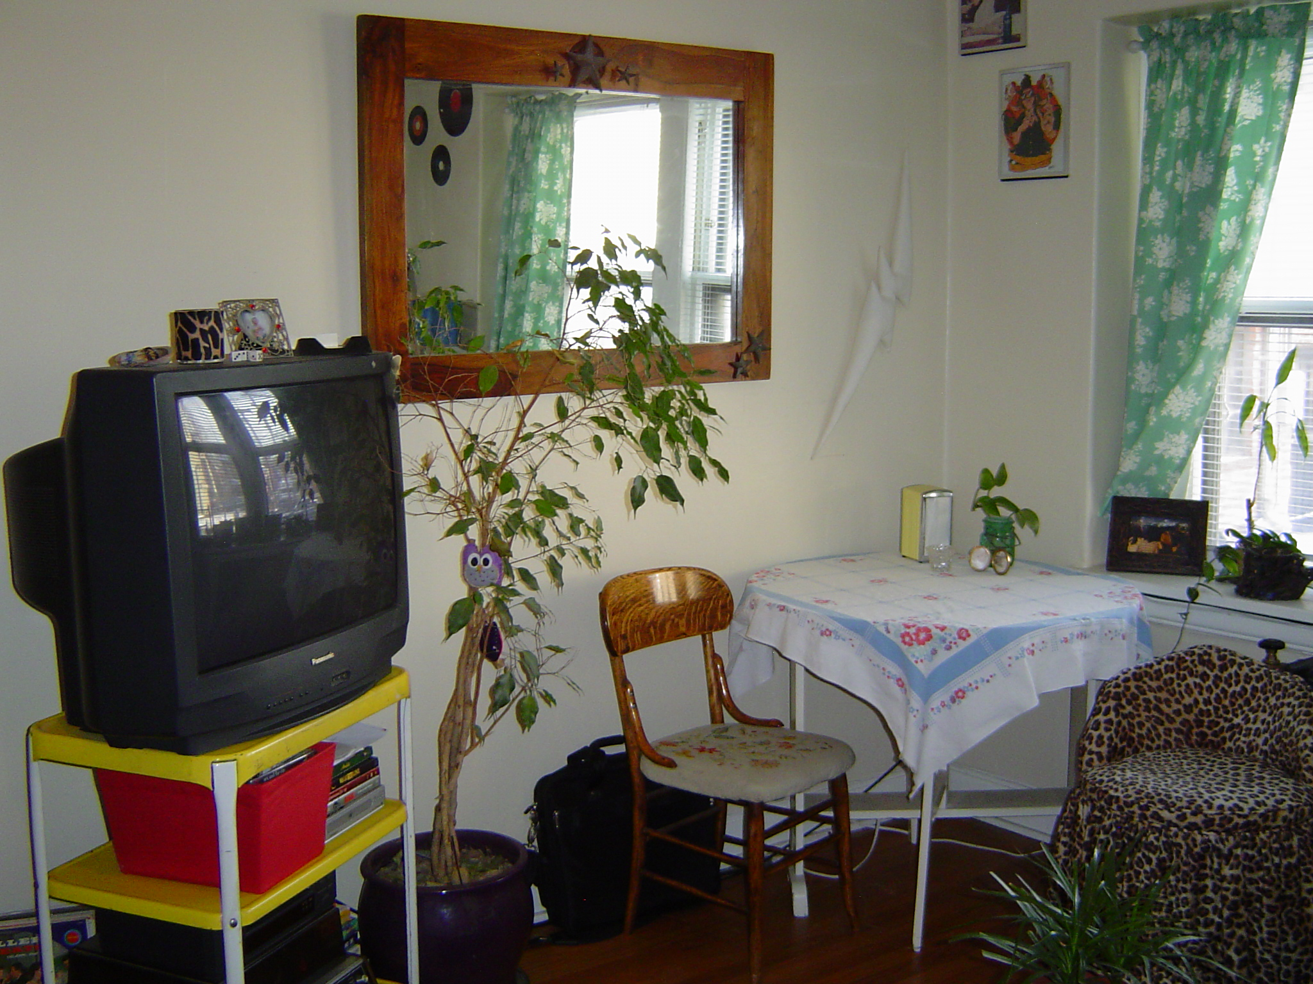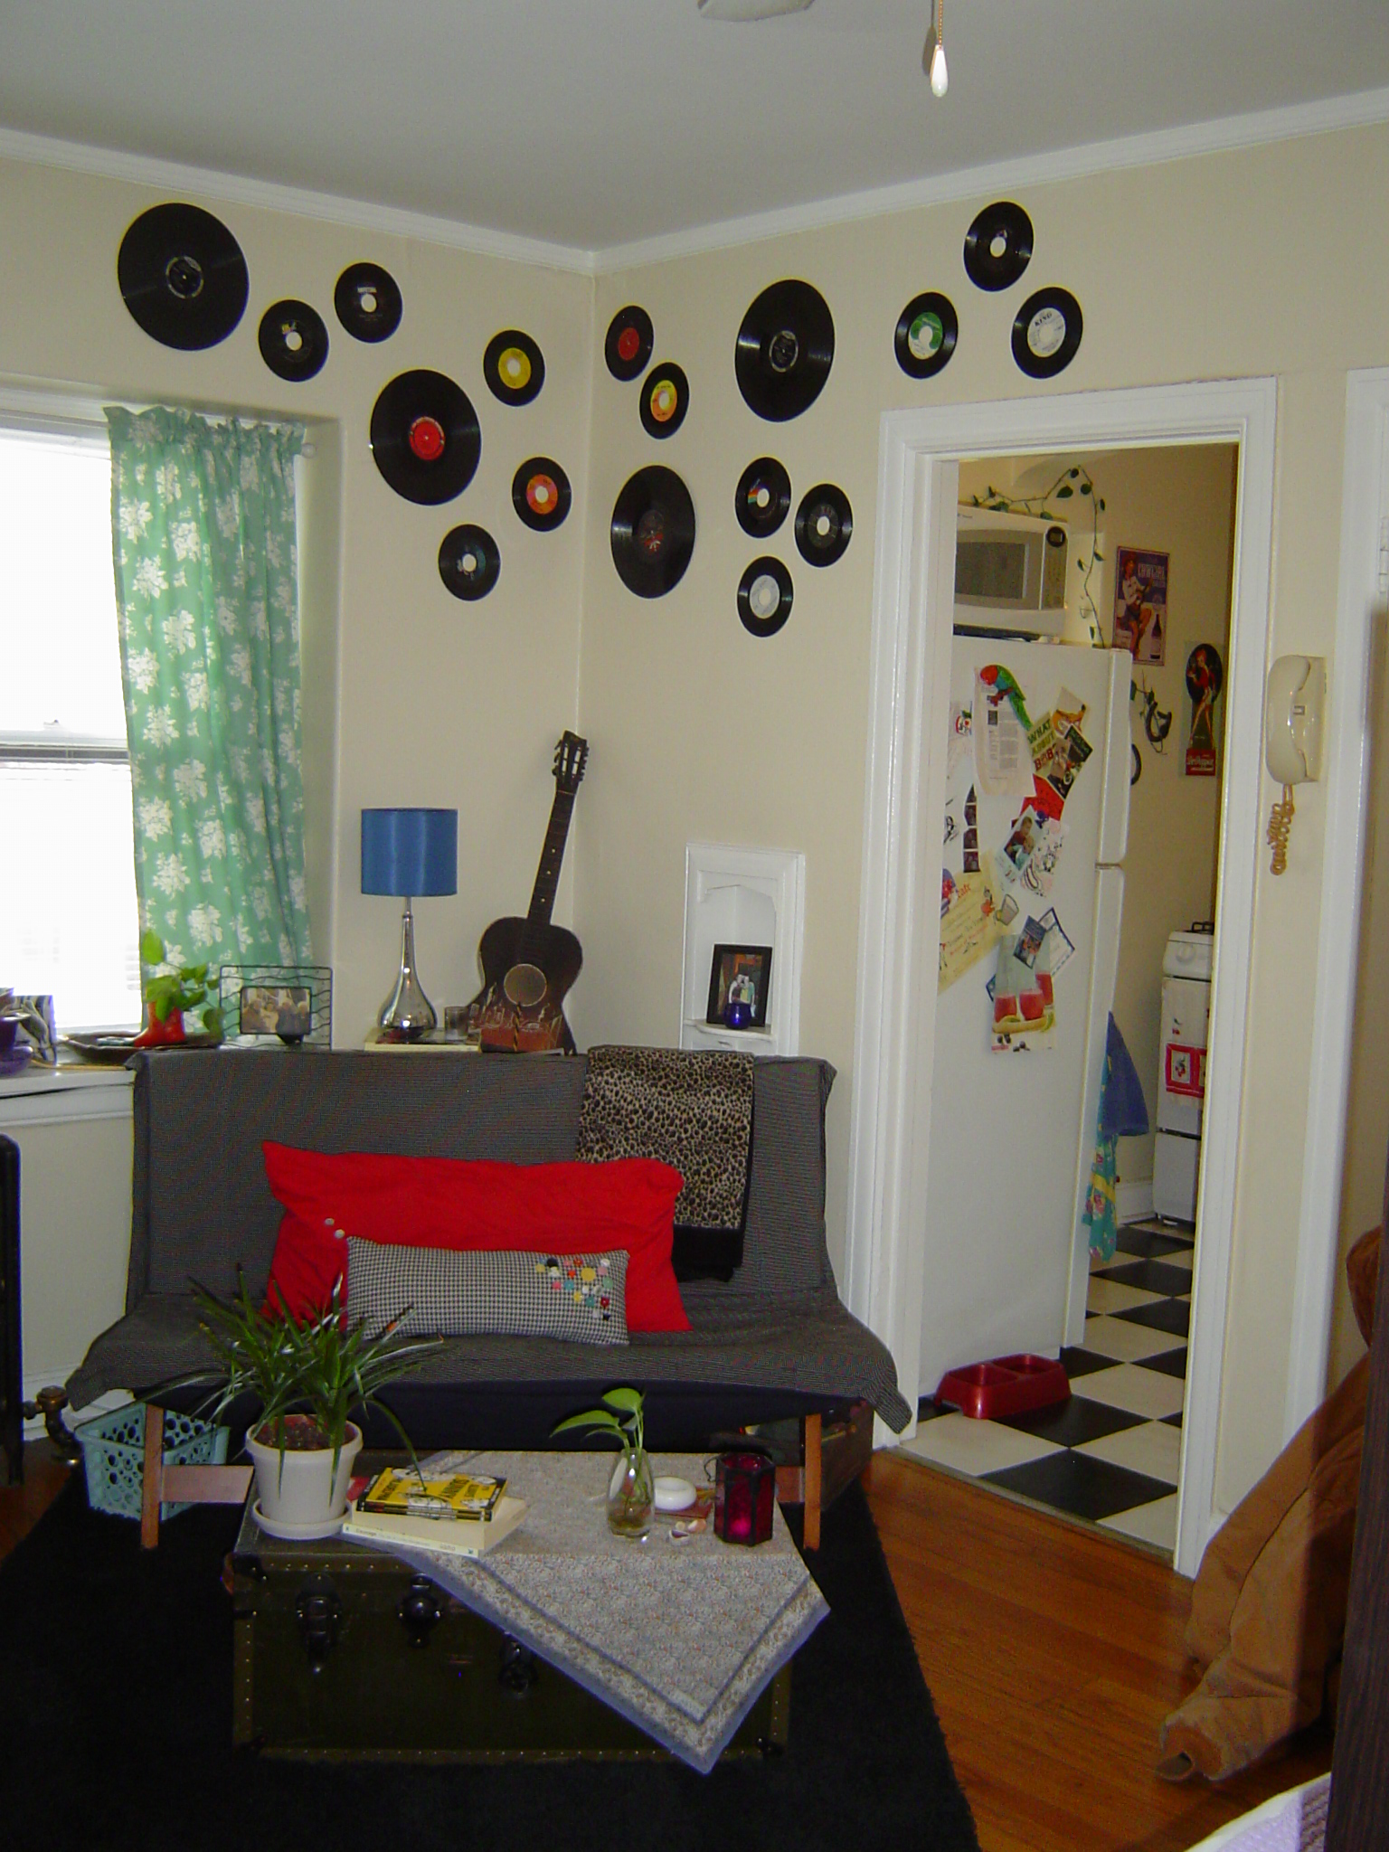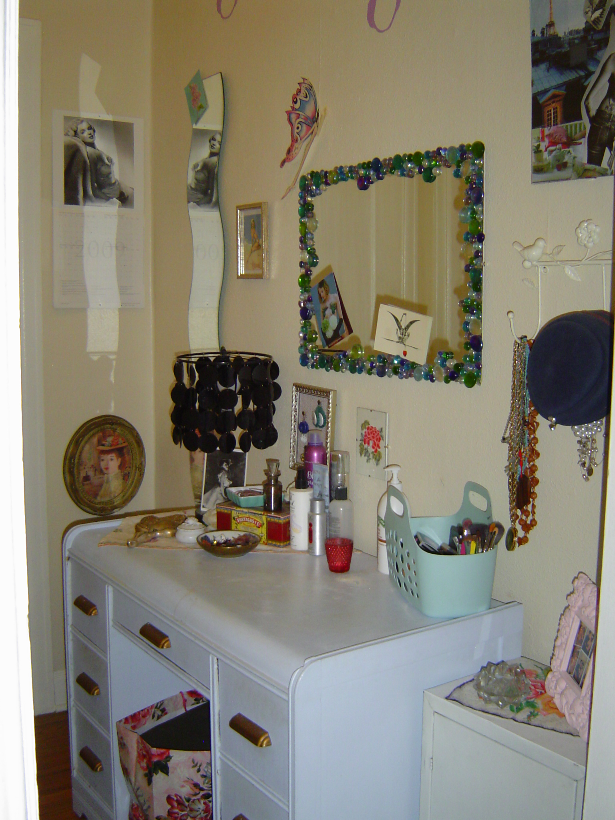

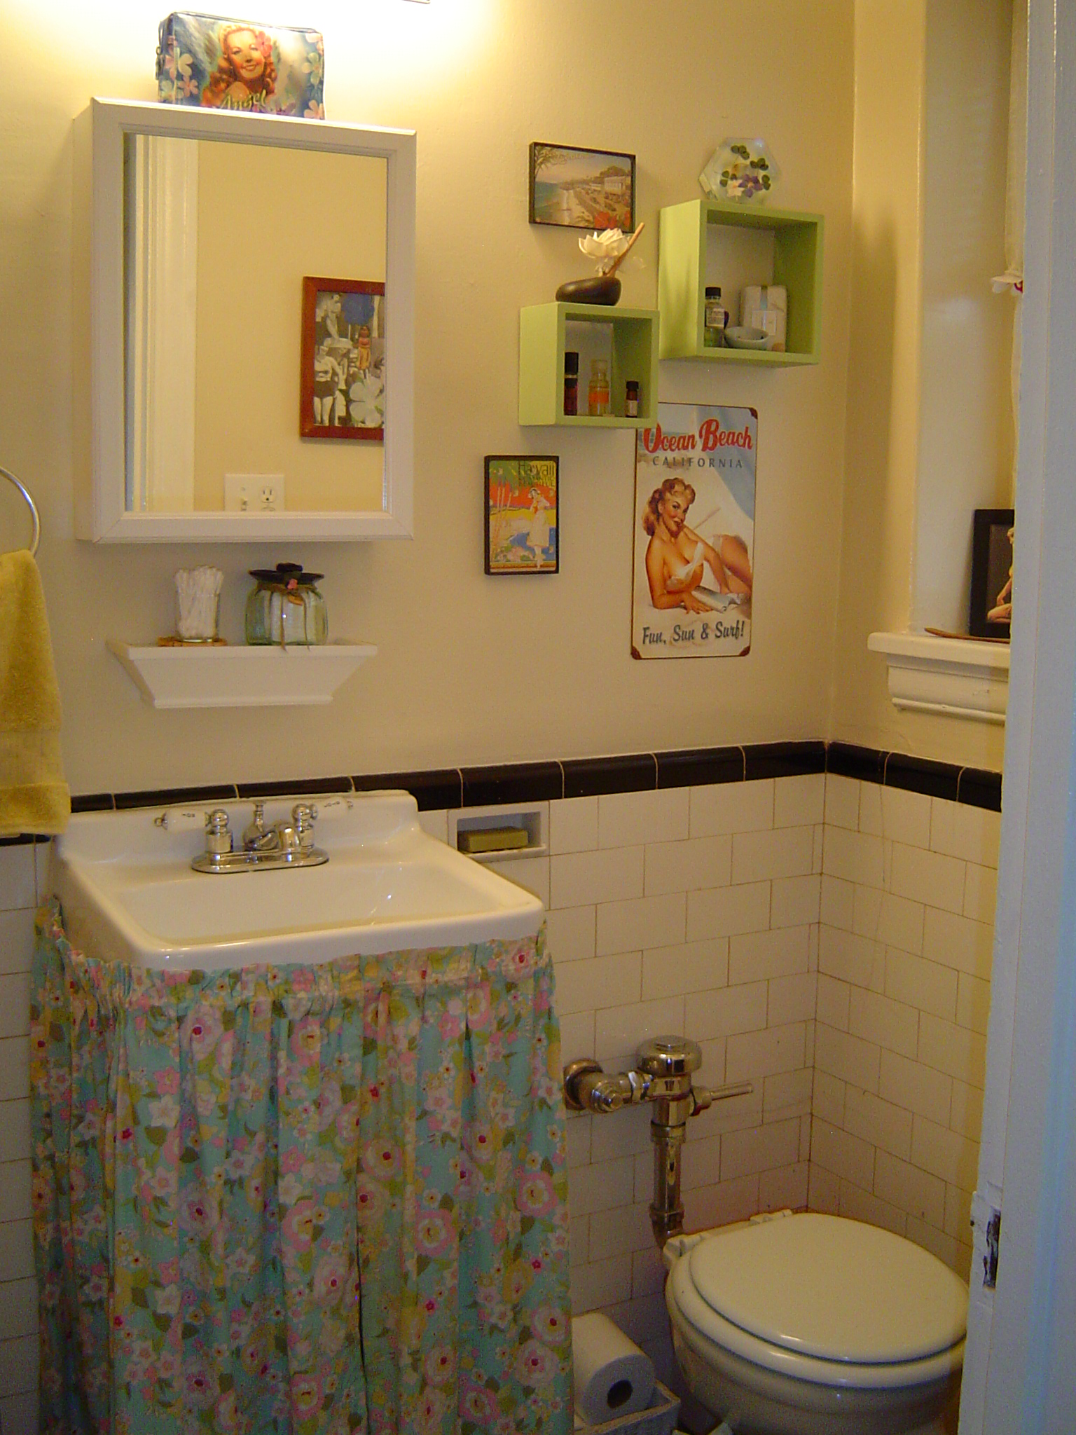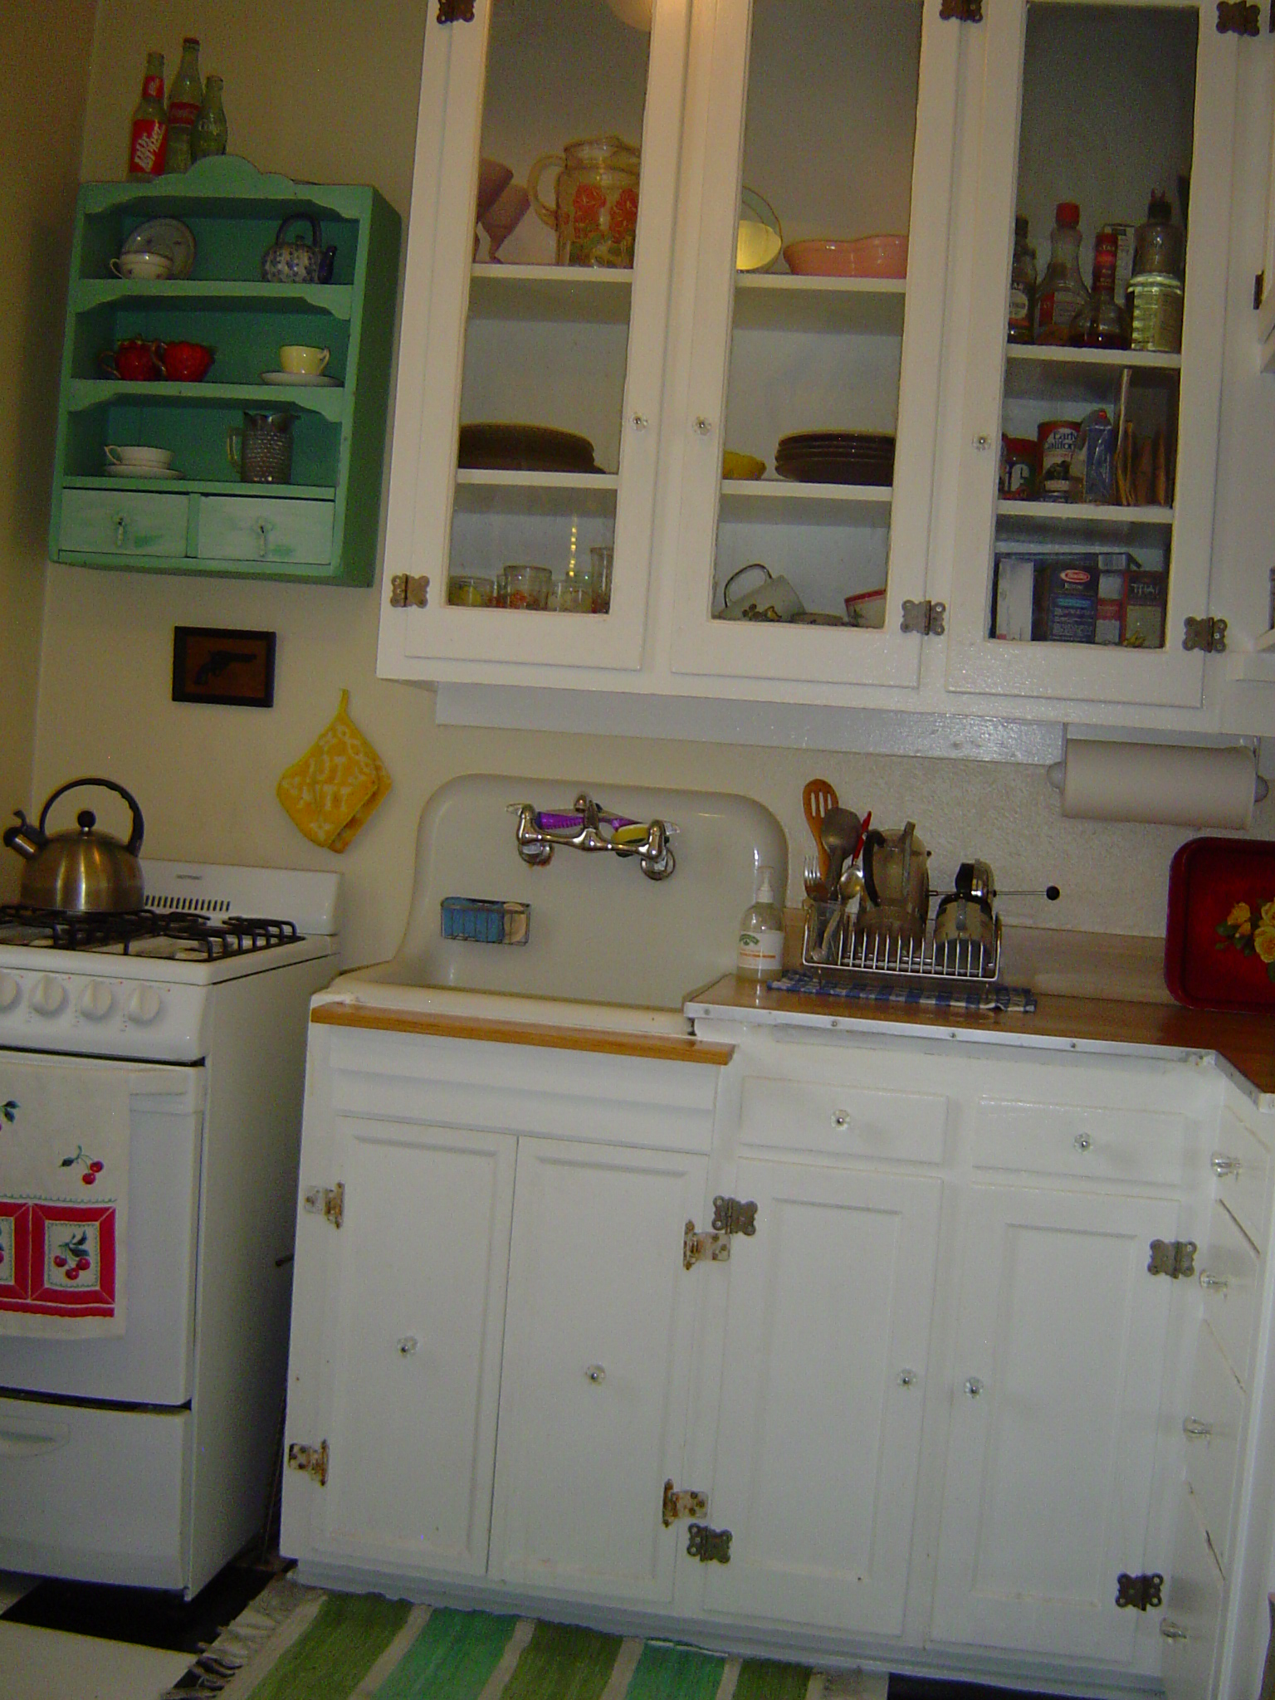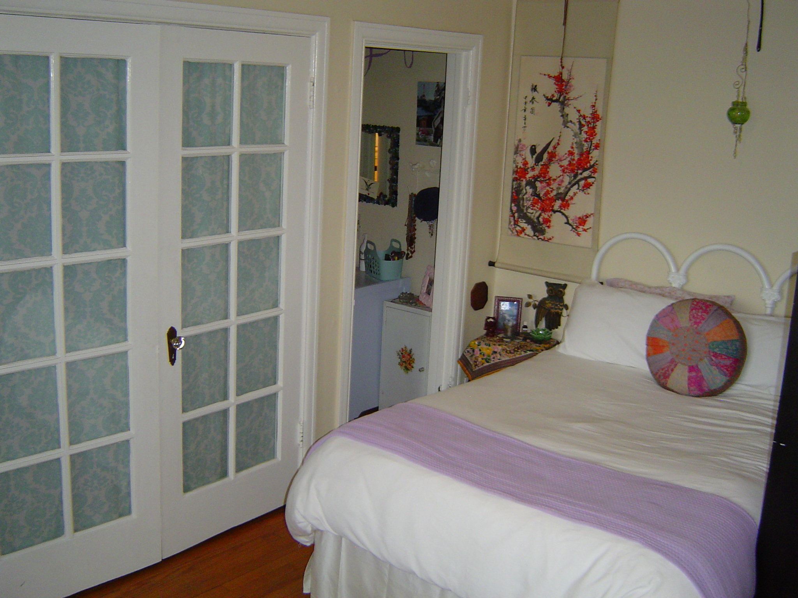
All apartments reflect classic vintage style featuring hardwood floors, restored woodwork, Art Deco tile, & cottage style kitchens.

Charming Studios-$645-$695

Spacious 1 bedrooms-$785-$795

ALL UTILITIES INCLUDED!!!

Good Pets Accepted (additional deposit and pet fees apply)

