Live in Vintage Splendor at Park View Terrace

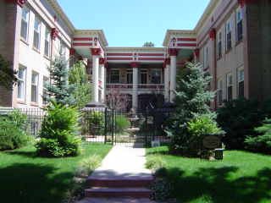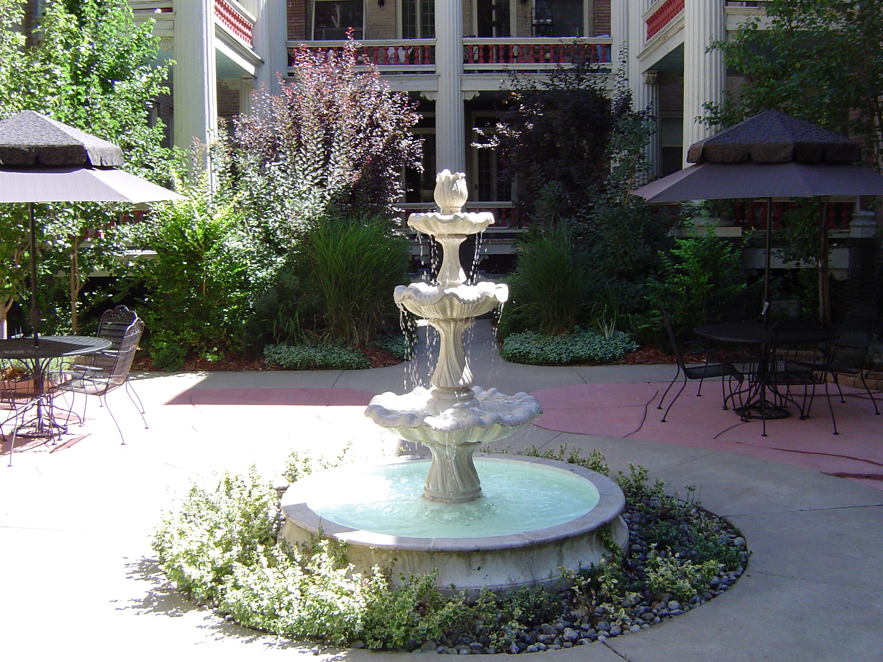
1680 Steele Street
Park View Terrace is located right across the street from City Park, which features “Jazz in the Park and paddle boat rentals in the Summer, and just blocks away from Denver’s Restaurant Row and Colfax shopping district. Built in 1910 as mansion-style rental residences, Park View Terrace maintains much of the original character present at that time. Recently restored common areas feature period style lighting, in addition to new carpet and wall treatments. Beautifully landscaped courtyard creates areas to enjoy the wonderful Colorado weather.
Building features:
- Front gate security system
- Onsite Laundry Facilities
- Onsite Storage
- Patio and Grilling area
- Period Style carpeting and lighting
- Balcony space in select units
- Non smoking building & apartments
Apartments feature:
- Rent includes all utilities except electricity
- Newly refinished hardwood floors
- Beautiful Crown molding and original trim
- Designer Paint Schemes
- Abundant closet space
- Restored Kitchens with new appliances
- Huge windows-lots of natural light

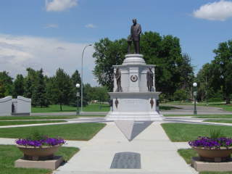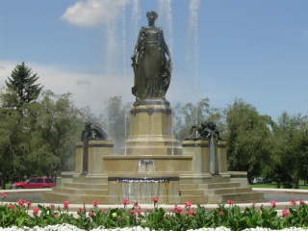
Mansion-style apartments on the park. . .

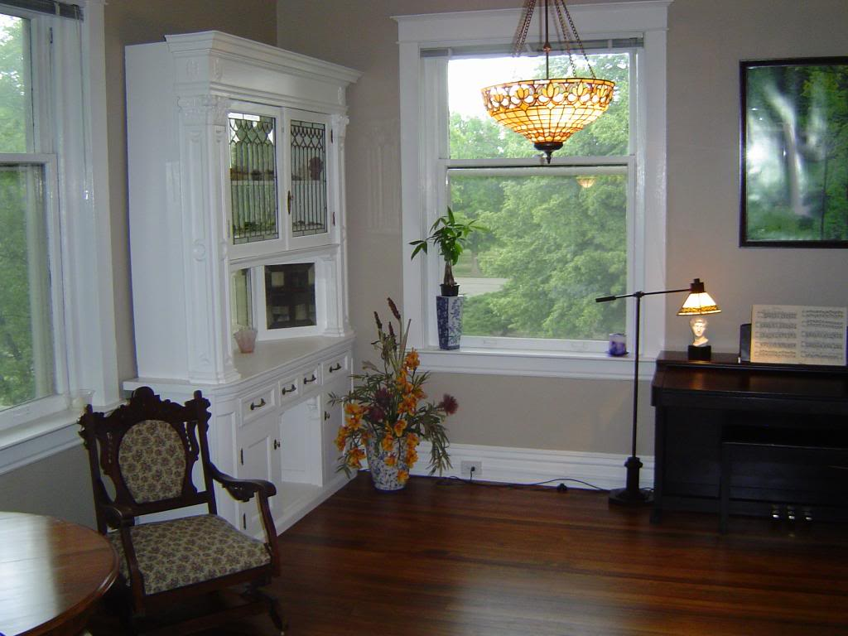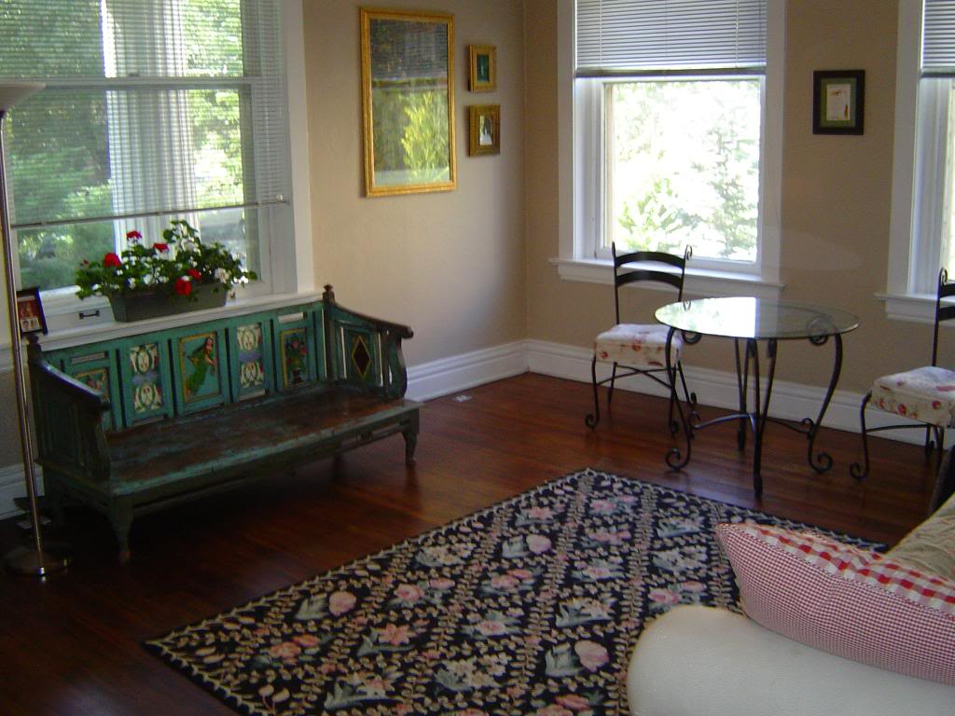

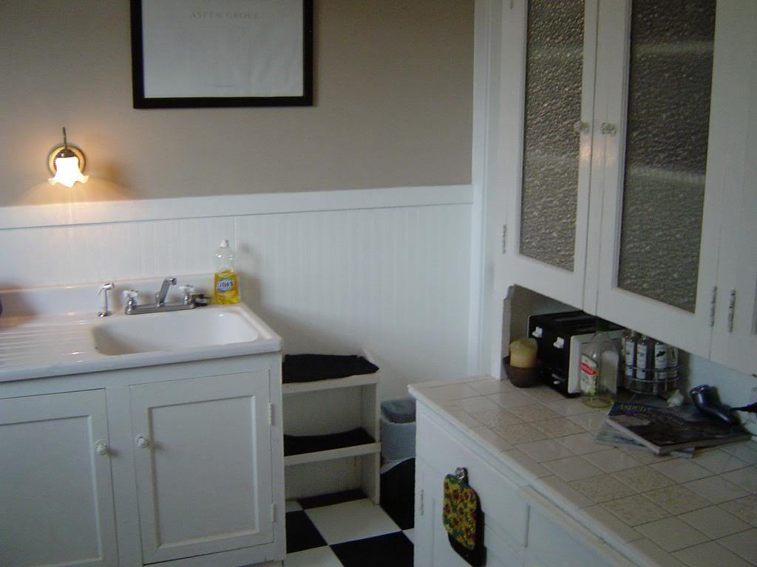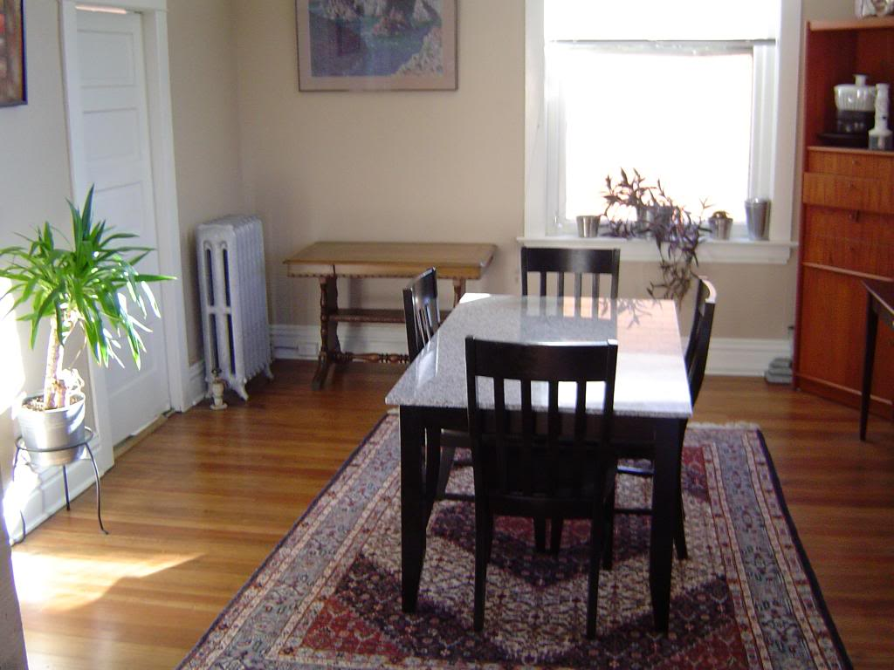

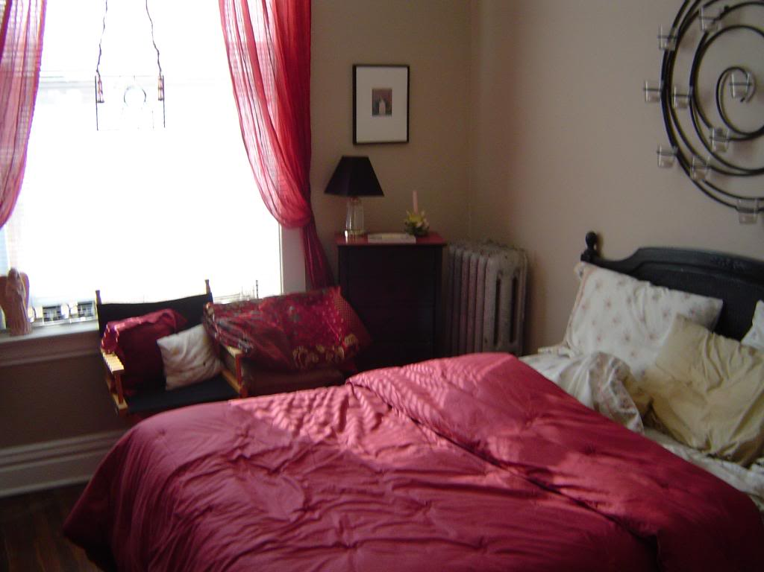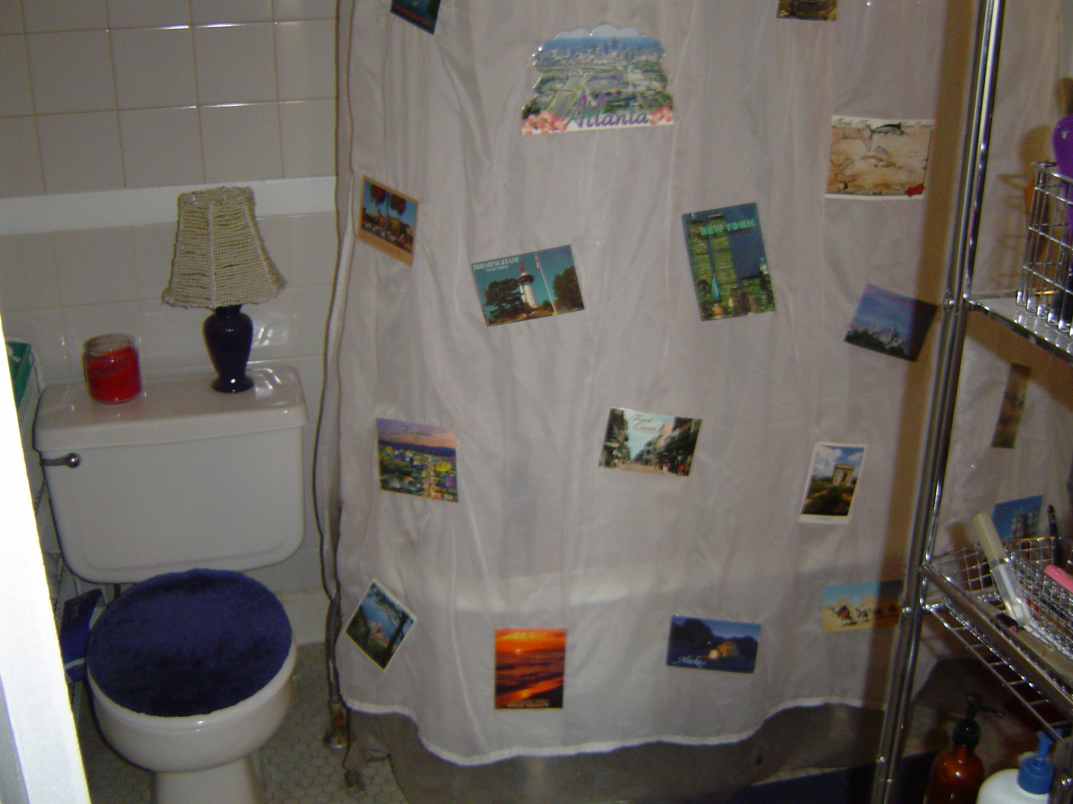

HUGE 1 bedrooms with dining rooms & balconies (select units)--$985-$1195
Large 2 bedrooms--$995-$1195

